A

PROJECT REPORT

ON

**“network based wireless pa system”**

SUBMITTED to SAVITRIBAI PHULE PUNE UNIVERSITY

FOR PARTIAL FULFILLMENT

OF THE REQUIREMENTS for the DEGREE OF

**BACHELOR OF ENGINEERING**

IN

**ELECTRONICS AND TELECOMMUNICATION**

**ENGINEERING**

BY

|  |  |
| --- | --- |
| **ADITI KULTHE** | **B121023001** |
| **KEDAR KAWARE** | **B121023023** |
| **SARVAR NADAF** | **B121023031** |

UNDER THE GUIDANCE OF

**Mrs. N. V. DHOLE**



**DEPARTMENT OF ELECTRONICS AND TELECOMMUNICATION**

**RMD SINHGAD SCHOOL OF ENGINEERING, RMDSTIC**

**WARJE, PUNE – 411058**

**2017-18**

**Department of Electronics and Telecommunication Engineering**

**RMD Sinhgad School of Engineering, Pune-58.**

**CERTIFICATE**

This is to certify that the project report entitled

**“NETWORK BASED WIRELESS PA SYSTEM”**

submitted by

**ADITI KULTE**

**KEDAR KAWARE**

**SARVAR NADAF**

is a bonafide work carried out by them under the supervision of Mrs. N. V. Dhole and it is approved for the partial fulfillment of the requirement of Savitribai Phule Pune University, for the award of degree of

**Bachelor of Engineering,**

**Electronics and Telecommunication**

This project work has not been earlier submitted to any other Institute or University for the award of any degree or diploma.

Mrs. N. V. Dhole

**Guide**

Mrs. Snehal Bhosale Prof. Dr. V. V. Dixit

**HOD (E&TC Dept.) Principal**

Place: Pune

Date: (External Examiner)

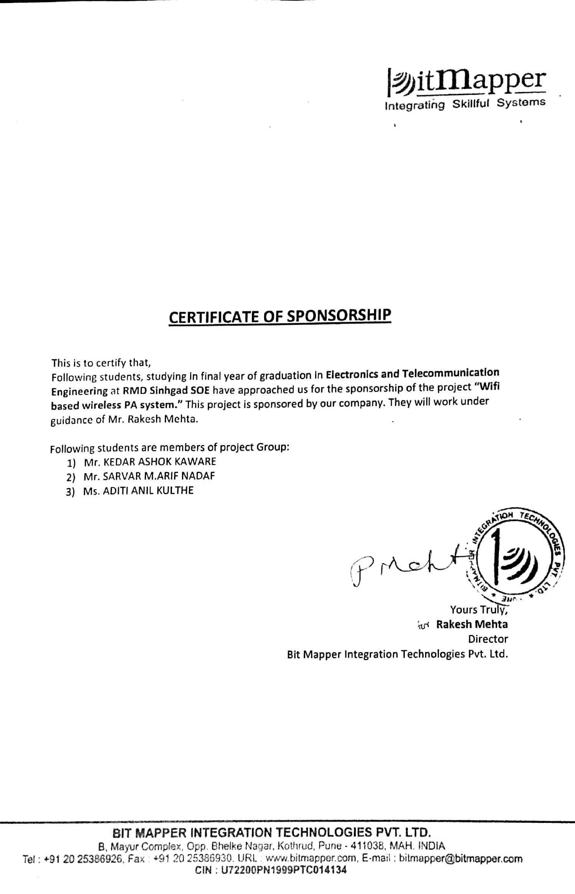

**ACKNOWLEDGEMENT**

I am personally indebted to a number of people who gave me their useful insights to aid in my overall progress for this project. A complete acknowledgement would therefore be encyclopedic. First of all, I would like to give my deepest gratitude to my parents for permitting me to take up this course.

My heartfelt sense of gratitude goes to our respected Principal **Prof**. **Dr. V. V. Dixit** for all his efforts and administration in educating us in his premiere institution. I take this opportunity to also thank ourHead of the Department, **Mrs. Snehal Bhosale** for her encouragement throughout the project.

I would like to express my sincere thanks and gratitude to my guide, **Prof. N. V. Dhole** for his commendable support and encouragement for the completion of project with perfection.

I also convey my sincere thanks to our project **Mr. R. U. Shekokar** for her invaluable suggestions and for her technical support rendered during the course of my project.

I would like to thank all faculty members and staff of the Department of Electronics and Communication Engineering, RMDSSOE for their generous help in various ways for the guidance of this project.

Aditi Kulthe

Kedar Kaware

Sarvar Nadaf

**CONTENTS**

|  |  |  |  |  |
| --- | --- | --- | --- | --- |
| Abstract i | | | | |
| List of Figures iv | | | | |
|  | | | | |
| **1** |  |  | **Introduction** | 01 |
|  | 1.1 |  | Voice Over WLAN | 01 |
|  | 1.2 |  | Project Overview | 03 |
|  | 1.3 |  | Objective | 05 |
|  | 1.4 |  | Relevance | 06 |
|  | 1.5 |  | Scope | 06 |
|  | 1.6 |  | Organization of the Report | 06 |
| **2** |  |  | **Literature survey** | 08 |
| **3** |  |  | **Block Diagram & Circuit Diagram** | 08 |
|  | 3.1 |  | Block Diagram | 08 |
|  | 3.2 |  | Block Description | 08 |
|  |  | 3.2.1 | Raspberry Pi | 09 |
|  |  | 3.2.2 | Amplifier | 12 |
|  |  | 3.2.3 | Wi-Fi Router | 14 |
|  |  | 3.2.4 | Microphone | 15 |
|  |  | 3.2.5 | Audio/Sound Card | 17 |
|  |  | 3.2.6 | SD Card | 19 |
| **4** |  |  | **Project Methodology** | 20 |
|  | 4.1 |  | Software | 20 |
|  |  | 4.1.1 | ICECast 2 | 20 |
|  |  | 4.1.2 | Python | 22 |
|  |  | 4.1.3 | Basic4Android | 23 |
|  | 4.2 |  | Implementation Of System | 27 |
|  |  | 4.2.1 | Design Flow | 27 |
|  | 4.3 |  | Algorithm Of System | 28 |
|  | 4.4 |  | Flow Chart Of System | 29 |
| **5** |  |  | **Implementation Results** | 30 |
|  | 5.1 |  | ICECast 2 Broadcasting | 30 |
|  | 5.2 |  | Andriod App | 32 |
| **6** |  |  | **Conclusion** | 34 |
|  | 6.1 |  | Conclusion | 34 |
|  | 6.2 |  | Future Scope | 34 |
|  | 6.3 |  | References | 35 |
|  | 6.4 |  | Websites | 36 |
|  |  |  |  |  |
|  |  |  |  |  |
|  |  |  | **Publications** |  |
|  |  |  | **Certificates** |  |
|  |  |  | **Data Sheets** |  |

**ABSTRACT**

The real-time voice transmission over wireless medium is being exploited by various newest of applications, with increasing demands of Electronics products in the domain of the industrial & Consumer application, it becomes necessary to come up with new ideas of electronic products. In the field of communication, present real- time communication audio transmission uses technologies like WiMAX, IEEE 802.11, 3G and Bluetooth. But audio-streaming through Bluetooth or radio waves have drawbacks of range and not secure as intruders can get streamed feed. In this project a fully-functional has been proposed which is able to stream or transmit audio in real-time over Wi-Fi (IEEE 802.11). This system uses a small credit card sized single board called Raspberry Pi, MIC, android smartphones, Wi-Fi and headphone/speakers. This system is a standalone system and does not require any single PC to take or receive the data from headphone/MIC and send to another user. Operating speed of this platform is in 700MHz and it supports live audio streaming. As it has on board Audio codec, it is possible to connect to user by just accessing the IP address of another user. This system uses a small credit card sized single board called Raspberry Pi, display, webcam, Wi-Fi and headphone/speakers. This system is a standalone system and does not require any single PC to take or receive the data from camera and headphone/MIC and send to another user. Operating speed of this platform is in 700MHz and it supports live audio streaming. As it has on-board Audio codec, it is possible to connect to user by just accessing the IP address of another user. SSH (Secure Shell) is used for secure data communication, remote command-line login, remote command execution, and other secure network services between two networked nodes. Open source Linux based OS is used to keep the cost low.

i

## LIST OF FIGURE

|  |  |  |
| --- | --- | --- |
| **Figure No.** | **Name of Figure** | **Page No.** |
| 1.1 | Voice Over Wi-Fi | 02 |
| 3.1 | Block Diagram Of System | 08 |
| 3.2.1 | Raspberry Pi | 10 |
| 3.2.2 | Raspberry Pi Desktop | 11 |
| 3.2.3 | Circuit Diagram Of Amplifier | 12 |
| 3.2.4 | PCB Layout of Amplifier | 13 |
| 3.2.5 | Wi-Fi Router | 14 |
| 3.2.6 | Microphone | 16 |
| 3.2.7 | Sound Card | 17 |
| 3.2.8 | Sound Card With Raspberry Pi | 18 |
| 3.2.9 | SD Card | 19 |
| 4.1.1 | ICECast 2 Status | 20 |
| 4.1.2 | ICECast 2 Programming Window | 21 |
| 4.1.3 | Initial Booting of Raspberry Pi | 23 |
| 4.1.4 | Basic4Android Programming window | 24 |
| 4.1.5 | Actual View of Android App | 25 |
| 4.4 | Flowchart of The Proposed System | 29 |
| 5.1.1 | ICECast 2 Program | 30 |
| 5.1.2 | ICECast 2 Program Execute in Terminal | 30 |
| 5.1.3 | IP Adress In URL | 31 |
| 5.1.4 | Broadcasting Start In Raspberry Pi | 31 |
| 5.1.5 | Broadcasting Start in Mobile | 32 |
| 5.2.1 | Program For Android App | 32 |
| 5.2.2 | Execute Program in Terminal | 33 |
| 5.2.3 | Controlling Options in Android App | 33 |

ii